Matter Study Guide
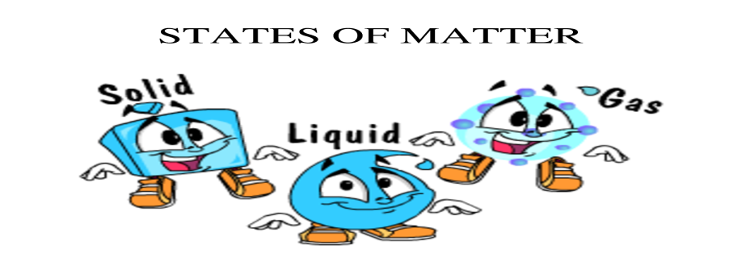
The open notebook test on Sept. 18 (Boisvert), Oct.9 (Dalessio), & Nov. 1 (Goncalves) will be multiple choice and short answer questions.
Please know the following vocabulary: solid, liquid, gas, properties, mixture, change, condensation, chemical, & physical reaction
*The study guide is just for you to review at home-it does NOT have to be turned into teacher!!!
- How can matter change?
- What is rust?
- How does the temperature of water affect the time it takes for a substance to dissolve?
- What changes occur when solids and liquids react chemically?
- What is a mixture and give an example?
- What is a property of liquid? (hint- does it look different in different containers?)

