Please color in the days you read 20 minutes, make a goal, and answer questions below.
Reading Log

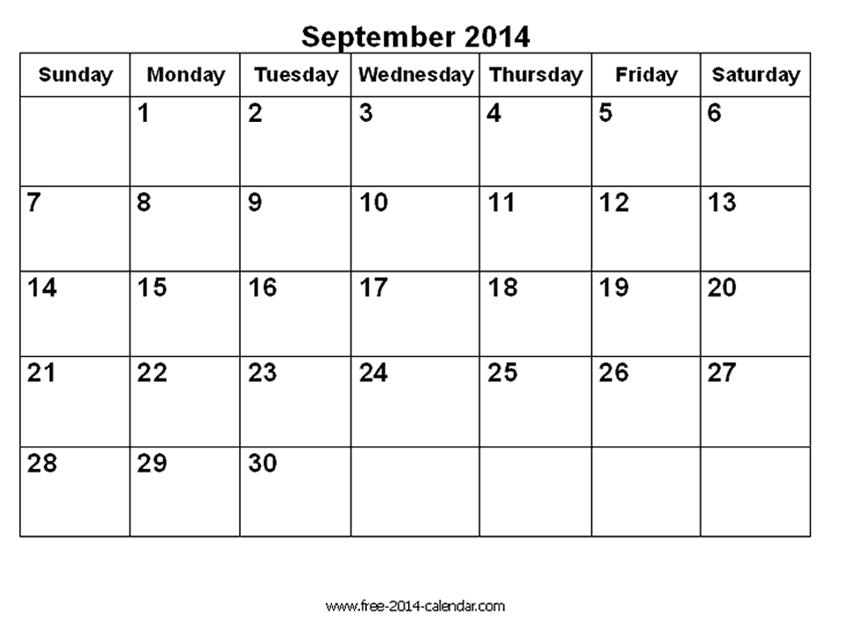
Weeks of Sept. | My Goal | Days I read | Parents Initials | Student Signature
Week 1
Week 2
Week 3
Week 4
There are 30 days in September. If you read for 20 minutes every day that would be 600 minutes for the month. What is your total?
Connected Classroom Questions:
- My thin question (one specific word answer) is________________________________
Answer is _______________________________________
- My thick question (answer has several sentences) is _______________________________________________
Answer is _______________________________________________
_______________________________________________

